Overview
The Contact details screen displays your phone, email, postal and residential address details as known by the department. You can update your contact and address details when your circumstances change.
Updating your contact details ensures the department can continue to stay in touch with you, and you will continue to receive the appropriate level of benefits based on your location and living circumstances.

The Contact details screen.
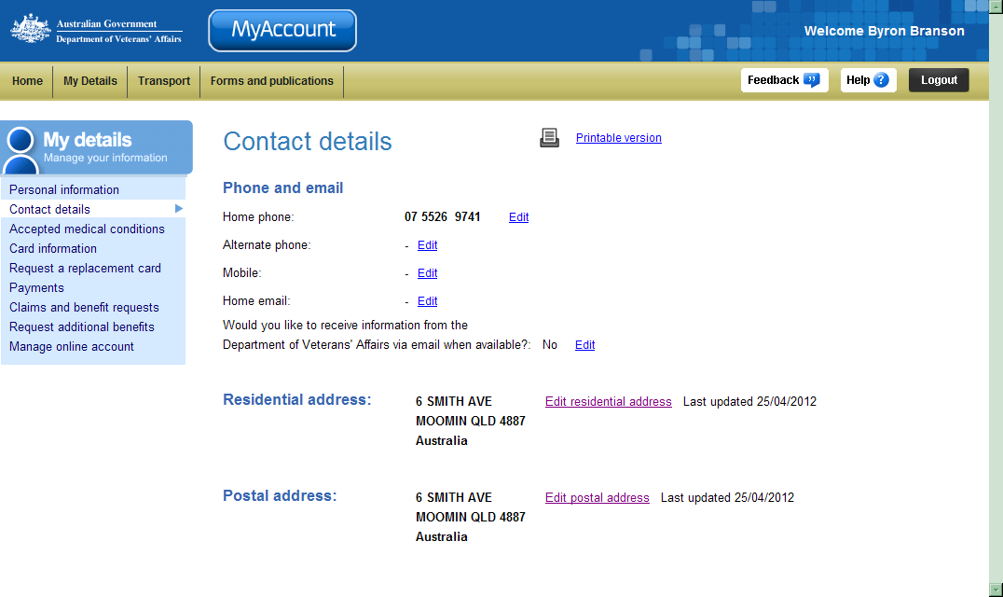
My details menu
Phone and email details
Address
details

Editing phone and email details
You can edit phone and email details both for locations within Australia and overseas.
To update phone or email details:
- Click on the Edit link beside listing.

The Edit phone and email details screen displays.
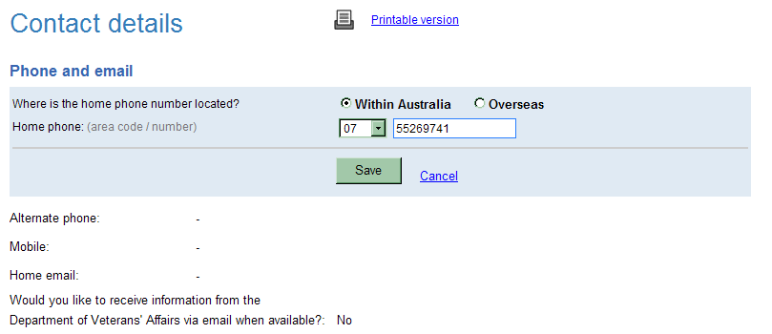

For phone numbers located in Australia
- From the Home phone drop down list, select the correct area code and enter your home phone number without spaces.
Ensure you avoid spaces between digits in your phone numbers. For example: 67890123 or for a mobile, 0412789012 rather than 0412 789 012.
- In the Mobile field, enter your mobile phone number (if you have one).
- The Alternate phone field may be used if you have a business or other number.
- In the Home email field, enter your home or personal email address.
Your email address must contain the ‘@’ symbol and no spaces. For example: johncitizen@email.com.au. Note that email addresses are not case sensitive.

For phone numbers located overseas
- In the Home phone field, enter your home phone number in the form:
<Country code> <Local area code> <Local phone number>
Example
For a phone number in the UK is listed as: 01970 623111 (when dialling from the UK).
Enter: 44 (country code) 1970 (area code) 623111 (local number)
When entering overseas phone and fax numbers, the following restrictions apply:
- Country code: maximum 5 characters
- Local area code: maximum 5 characters
- Local phone number: maximum 15 characters.
- In the Mobile field, enter your mobile phone number (if you have one) in the form:
<Country code> <Mobile phone number>
Example
For a mobile or cell phone number in the US is listed as (858) 518-4400 (when dialling from the US).
Enter: 1 (country code) 858 (area code) 5184400 (local number)
- In the Home email field, enter your home or personal email address.
- From the Would you like to receive information from the Department of Veterans’ Affairs via email drop down list, select your preferred option.
- Click on the Next button.

The Contact details screen updates.
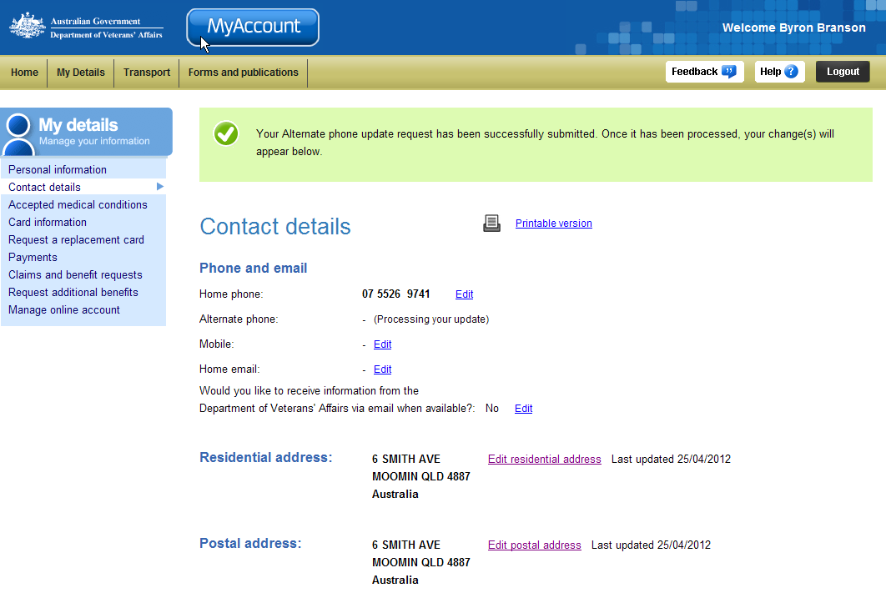
At the top of the screen, a green success message states your contact details have been submitted for processing. Once the request has been processed and validated, your changes will appear in the Contact details area.
- Check the phone and email details are correct.
 | If you need to make changes to any of the phone and email details, click on the ‘Edit details’ button.
- Click on the Save button.

Editing residential address details
When updating your residential address, you will also be asked who else will be moving to the new address with you and whether the move is permanent or temporary.
Note that a post office (PO) box cannot be used as a residential address.
To update your residential address:
- From the Contact details screen, click on the Edit residential address link.

The Edit residential address screen displays.
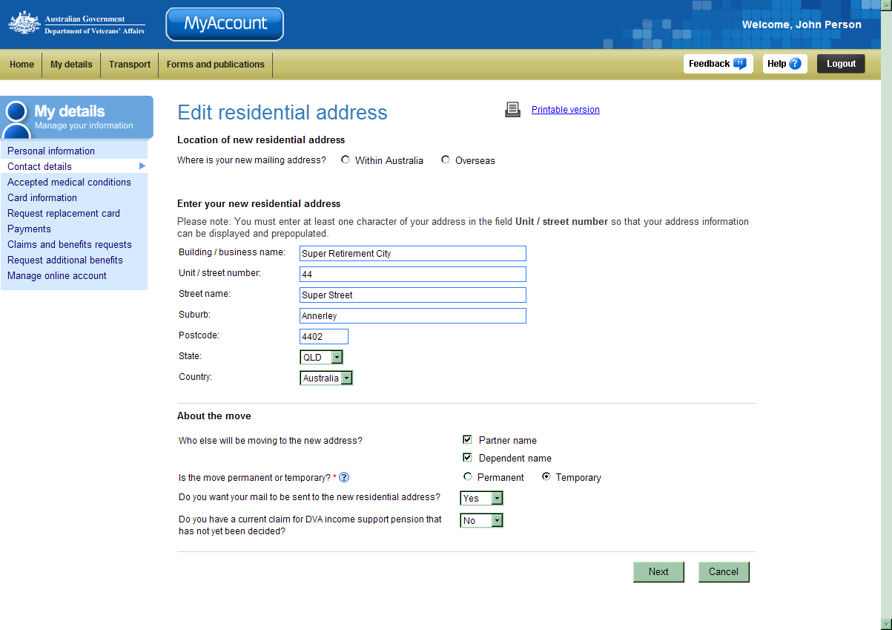
- For the Where is your new mailing address? question, select the appropriate option.

For addresses located in Australia
- In the Building / business name field, enter the name of the building, organisation or community your residential address is located in, if required.
- In the Unit / street number field, enter your unit, apartment or house street number.
The ‘Unit / street number’ field has pre-emptive address capability meaning you can type your address details and select from a supplied dropdown list. Once selected, all fields will be updated with the found data. This can be further edited if required.
- In the Street name field, enter name of the street your residential address is located on.
When entering your street name, include a full description for the street type.
For example: Street, Drive, Close or Boulevard.
- Provide the additional address details.
- From the Is this a local council relocation of your current address? drop down list, select the appropriate answer.
- If asked, indicate who else from your household will be moving to the new address?
- If asked, select the appropriate option for the Is the move permanent or temporary? question, select the appropriate option.
Choose ‘Temporary’ if you are holidaying or moving temporarily.
Choose ‘Permanent’ if you do not intend to return in the foreseeable future.
Note that if you have a Pensioner Concession Card (PCC) you may not be able to access some concessions in that state. If you select Permanent, a new PCC will be issued to you.
- From the Do you want your mail to be sent to the new residential address? drop down list, select the appropriate option.

For addresses located overseas

The Edit residential address screen displays an error message.
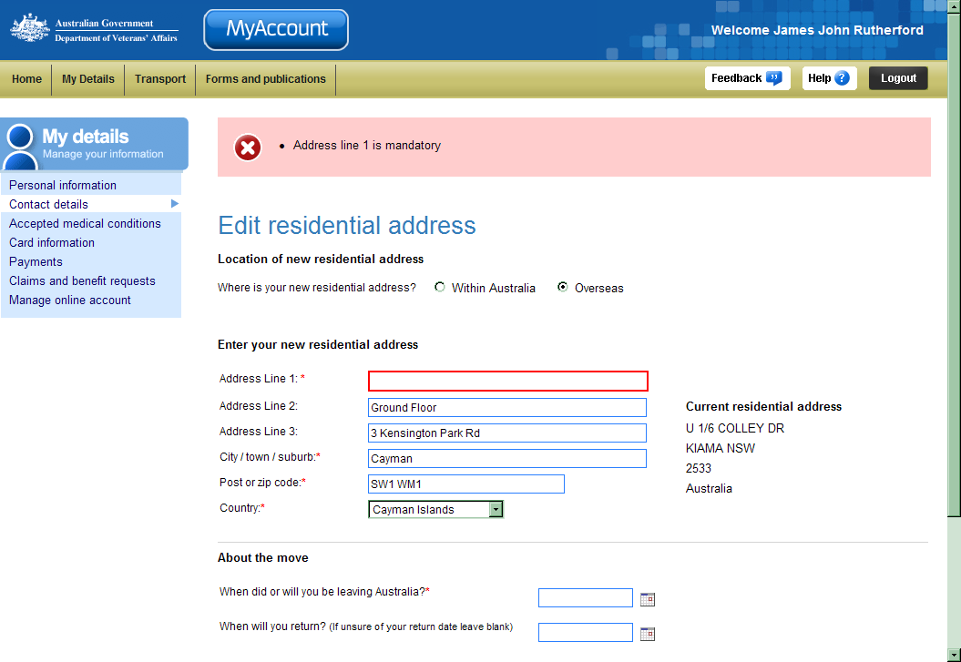
In this example a mandatory (required) field has been left blank and an error message has been presented at the top of the screen.
Ensure you complete all lines marked with an asterisk.
- In the Address fields, enter your address details. Include any building name, street name and house, unit or apartment numbers.
- From the Do you want your mail to be sent to the new residential address? drop down list, select the appropriate option.
- From the Do you have any outstanding claims with Income Support in DVA? drop down list, select the appropriate option. Claims include Service pension, Income support supplement and the Age pension.
- If asked, indicate who else from your household will be moving to the new address?
- Click on the Next button.

The Confirm residential address screen displays.
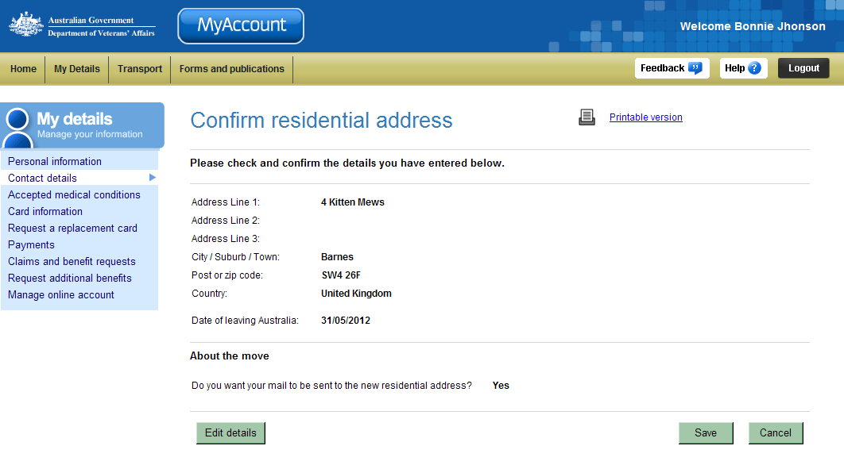
- Check your residential address details are correct.
If you need to make changes to any of the address details, click on the ‘Edit details’ button.
- Click on the Save button.

The Notify overseas travel screen displays.
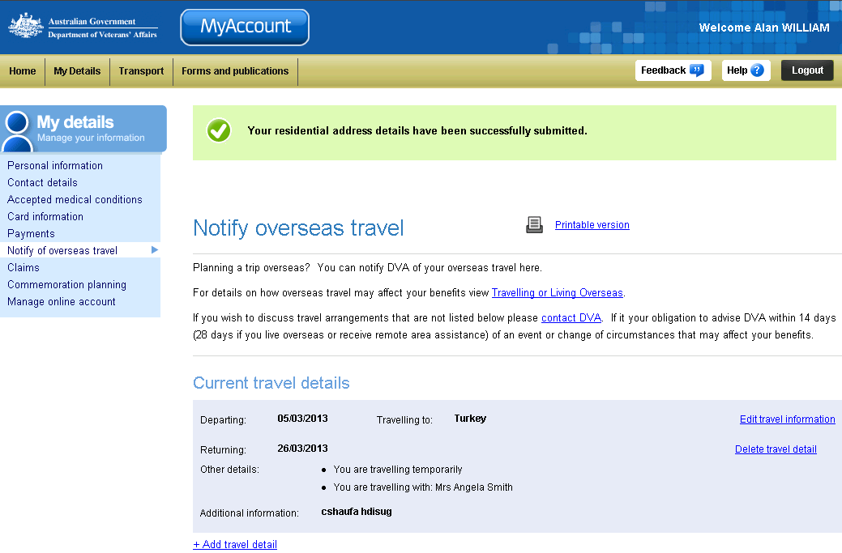
To assist you comply with DVA requirements for the notification of overseas travel, the Notify of overseas travel screen is presented.
Click the Help button () in the top right corner of the Notify of overseas travel screen for a step by step guide on how to notify DVA of overseas travel.

At the top of the screen, a green success message states your residential address details have been submitted for processing. Once the request has been processed and validated, your changes will appear in the Contact details area.

Updating postal address details
You can update your postal and work / business address as required.
To update your postal or work / business address:
- From the Contact details screen, click on the Edit postal address link.
- For the Where is your new postal address? question, select the appropriate option.

For addresses located in Australia
- In the Building / business name field, enter the name of the building, organisation or community your residential address is located in, if required.
- In the Unit / street number field, enter your unit, apartment or house street number.
- In the Street name field, enter name of the street your residential address is located on.
- In the Suburb / Town / City field, enter your suburb / town / city.
- in the Postcode field, enter your postcode.
- From the State drop down box, select your state.

For addresses located overseas
- In the Address Line fields, enter your postal address details. Include any building name, street name and house, unit or apartment numbers.
- In the City / Town / Suburb field, enter your city, town or suburb name.
- In the Post or Zip code field, enter your postcode or equivalent mailing code.
- From the Country drop down box, select the appropriate country.
- Click on the Next button.

The Confirm postal address screen displays.
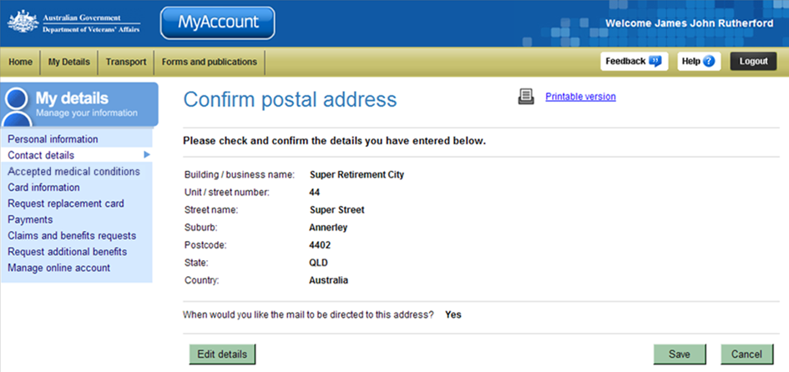
- Check your address details are correct.
If you need to make changes to any of the address details, click on the ‘Edit details’ button.
- Click on the Save button.

The Contact details screen updates.
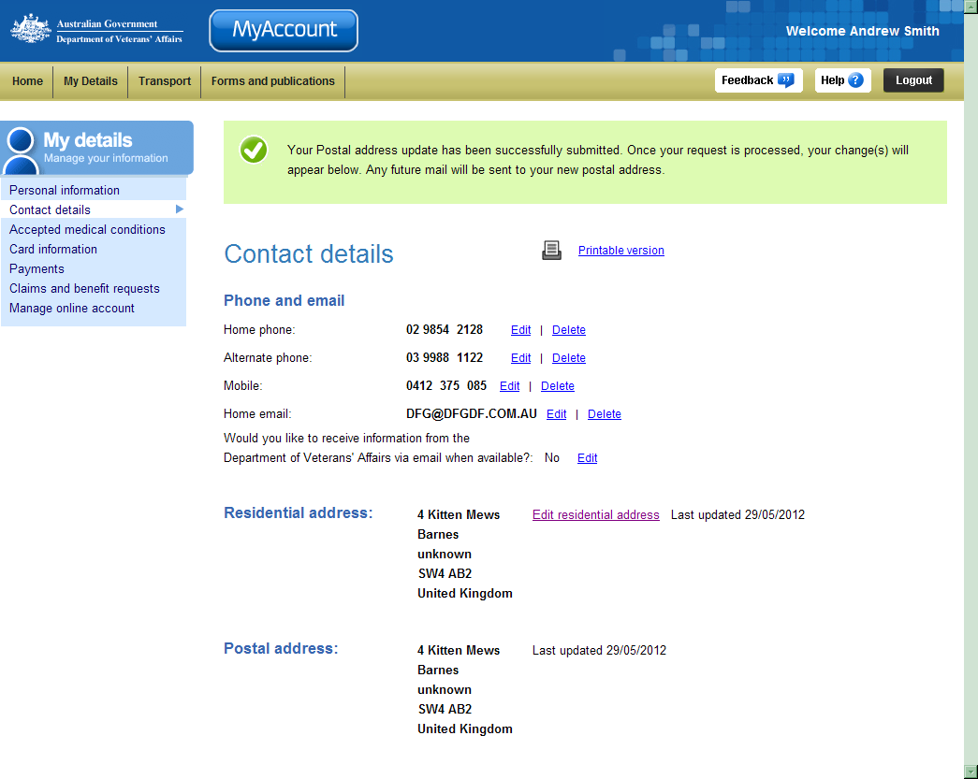
At the top of the screen, a green success message indicates your postal address details have been submitted for processing.
Once the request has been processed and validated, your changes will appear in the Contact details area.

Other functions
 | To view another section and information from My details, click on a link in the My details menu to the left of the page.
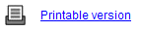 | To print a copy of the information displayed on this page, click on the Printable version link.
 | To get additional help with the Contact details screen, click on the Help button at to the top right of the page.
 | When you are finished using MyAccount, to log out and finish using the service in a secure way, click on the Logout button.

